Lesson 10.5 Force, weight and gravity
Recommended teaching time for this lesson: 1 x 60 minute period
• 35 minutes of explicit teaching
• 25 minutes of suggested classroom activities
• 45 minutes homework

Getting started

Key ideas
- Gravitational forces dictate an object’s weight.
- Normal force is the perpendicular force exerted on a body by a surface against which it is pressed.

Curriculum links

Science understanding
- Identify forces acting on an object.
- Determine the resultant force acting on an object in one dimension.

Advice for teaching this lesson

Things to know before you start teaching
It is very common when talking about mass to use the language that an object ‘weighs’ some number of kilograms. At this point in physics education, you should be very careful to use phrases like “has a mass of 20 kilograms” or “weighs 30 newtons” to model to students the correct use of language. In Unit 3 students will start learning about gravity fields, and so setting a foundation that weight is the force experienced due to mass in a gravity field at this point will benefit students in their later studies, as they will need to use this equation in this unit.
There are alternative versions of the starter activity depending on whether you have access to slinkies in your lab equipment. Consider purchasing yourself one from a cheap store for your own stock of physics equipment – colourful children’s toys make excellent demonstration tools.

Common misconceptions
- Watch for students using the terms ‘weight’ with the units of ‘kilograms’. While we all know what they mean, this is language that can cost them marks on assignments.

Differentiation strategies
Students struggling with free-body diagrams should be taught to always draw weight first, as it will be an easy constant. This will benefit them when they do 2D planes in Unit 3. Identify to students that the acceleration due to gravity can be found in the formula booklet.

Starter activity: Slinky demonstration (alternative 1)
Approximate time: 5 minutes
Activity placement: Place directly after Lesson overview
Activity summary: Physical demonstration of a slinky drop to ask students to consider ‘weight’.

Notes for the teacher
Do not use this version of the starter activity unless you have access to a slinky.
Watch this video for yourself so you know what four answers to propose: https://www.youtube.com/watch?v=wGIZKETKKdw
Encourage students to record their answer. A table on the board so that students feel slightly anonymised can be good to encourage participation.

Instructions for students
Step 1: Your teacher will demonstrate a slinky being held open. When prompted answer question ‘a’ below.
A slinky held under its own weight
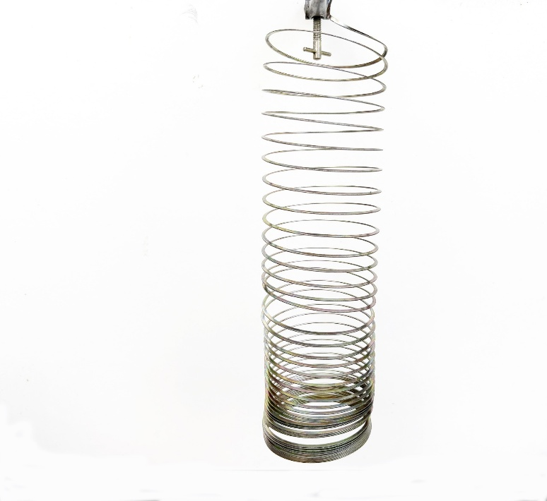
  - When the slinky is dropped which one of the following outcomes do you think will occur?
    - The bottom will fall first to the ground and then the top will fall.
    - The top will fall first and catch the bottom and then fall to the ground.
    - Top and bottom will fall together to the ground and then come together.
    - The centre will stay still and the slinky will compress before falling to the ground.
Step 2: Share your prediction with the class as requested by your teacher.

Answers
- Correct answer is ii.

Starter activity: Slinky demonstration (alternative 2)
Approximate time: 5 minutes
Activity placement: Place directly after Lesson overview
Activity summary: Video demonstration of a slinky drop to ask students to consider ‘weight’.

Notes for the teacher
Introductory video is: https://www.youtube.com/watch?v=wGIZKETKKdw
Answer video is: https://www.youtube.com/watch?v=eCMmmEEyOO0
If you wish to challenge the class, you could ask them whether the same would happen if this was repeated in space in low/zero gravity.

Instructions for students
Step 1: Watch the following video.
Slinky Drop: https://www.youtube.com/watch?v=wGIZKETKKdw
- When the slinky is dropped which one of the following outcomes do you think will occur?
- The bottom will fall first to the ground and then the top will fall.
- The top will fall first and catch the bottom and then fall to the ground.
- Top and bottom will fall together to the ground and then come together.
- The centre will stay still and the slinky will compress before falling to the ground.
Step 2: Watch the following answer video. Be honest and don’t watch this video until you have thought about and made your prediction for question ‘a’.
Slinky drop answer: https://www.youtube.com/watch?v=eCMmmEEyOO0.

Answers
- Correct answer is ii.

Classroom activity: Forces from space
Approximate time: 10 minutes
Activity placement: Place directly above “What do weight and gravitational forces look like in practice?”
Activity summary: A small writing activity to recap the last three lessons and combine it with this topic.

Notes for the teacher
Students can write in dot points as this is acceptable for exams.
If you wish to theme this towards practice for IA2 or IA3 writing, encourage students to plan and then ensure their writing does not ramble.

Instructions for students
Step 1: Think about an object falling from space.
- Explain how all three of Newton’s laws of motion apply to this scenario. Ensure your answer includes the words force, weight and gravity.

Answers
- The object is accelerating as it falls. This means that Newton’s first law of motion has been demonstrated as acceleration means that a motion is changing. The pull that the rock feels is known as weight because this is happening due to gravity. Because there is some value of acceleration this can be quantified in relation to the force of gravity which is Newton’s second law of motion. The third law of motion is non-obvious but the rock also exerts a gravitational force onto the Earth.

Classroom activity: Up or down?
Approximate time: 10 minutes
Activity placement: Place directly above “Check your learning 10.5”
Activity summary: An application question where students need to observe how gravity and weight appear and make inferences about situations that cause these observations.

Notes for the teacher
If you have a mass scale or balance beam scale, it could be beneficial to let students observe these as part of this activity.

Instructions for students
Step 1: Watch the following video, which shows a standard mechanical bathroom scale in a moving elevator. The elevator starts stationary, then starts to move, travels at a constant speed, and then stops.
Elevator physics: https://www.youtube.com/watch?v=FKwDluO8h5k
- Determine if the elevator is going up or down. Justify your answer by referring to the changes of values on the scale.

Helpful hints
- Identify the sequence of values that the scale reads. Remember the scale translates felt weight into a mass value.
- Don’t forget Newton’s first law.

Support activity

Notes for the teacher
This version asks students some specific scaffolding questions.

Instructions for students
Step 1: Watch the following video, which shows a standard mechanical bathroom scale in a moving elevator. The elevator starts stationary, then starts to move, travels at a constant speed, and then stops.
Elevator physics: https://www.youtube.com/watch?v=FKwDluO8h5k
- Identify the numbers that the scale reads when it is:
- Stationary
- accelerating at the start
- moving at a constant speed
- decelerating at the end.
  - Determine what happens to the weight on the scale at point ii. and point iv. above.
  - Justify which direction the elevator is moving: up or down.

Challenge activity

Notes for the teacher
This version asks an extension question about using a beam balance scale instead of a mass scale. A video answer is provided, but if you have a beam balance that students could examine this would contribute to their learning.
Ensure that students can see the answer for this level of the activity as a video demonstrating this experiment is included in the answers.

Instructions for students
Step 1: Watch the following video, which shows a standard mechanical bathroom scale in a moving elevator. The elevator starts stationary, then starts to move, travels at a constant speed, and then stops.
Elevator physics: https://www.youtube.com/watch?v=FKwDluO8h5k
- Determine if the elevator is going up or down. Justify your answer by referring to the changes of values on the scale.
- Propose if this would happen if a balance beam scale was used instead of a push operated scale. Your teacher may demonstrate a balance beam scale, or you can refer to the following video to see a balance beam scale in action.
Mass and using a triple beam balance: https://www.youtube.com/watch?v=stW-C7F7QOg

Answers
- The elevator is moving up. The scale starts at 70 kg, increases to 75 kg, returns to 70 kg, drops to 65 kg, and then finally stops at 70 kg. When the scale increases this means more weight is being placed upon it. This is an increased net force which indicates that an object is accelerating upwards in gravity. The 65 kg display indicates the opposite when the lift is slowing down.

Support activity
- 70 kg, (ii.) 75 kg, (iii.) 70 kg, (iv.) 65 kg
- At point (ii). the weight must increase since the mass reading increases. At point (iv.) the weight must decrease as the mass reading decreases.
- The elevator is moving up. Since the weight increases first this means the elevator is exerting a force upwards at the beginning. The weight drops when the elevator slows down and the object does not push as heavily on the scale.

Challenge activity
- The elevator is moving up. The scale starts at 70 kg, increases to 75 kg, returns to 70 kg, drops to 65 kg, and then finally stops at 70 kg. When the scale increases this means more weight is being placed upon it. This is an increased net force which indicates that an object is accelerating upwards in gravity. The 65 kg display indicates the opposite when the lift is slowing down.
- No it does not. The changes in weight seen in the first scale happen equally to both sides of the balance beam, so this version is not affected by external accelerations. A demonstration is here: https://www.youtube.com/watch?v=H4Cdm0xU0ps

